Module 3 – 5 marks
- What is an electric field? Obtain an expression for electric field intensity due to line charge.
- Obtain an expression for electric field intensity due to surface and volume charge
Ans:
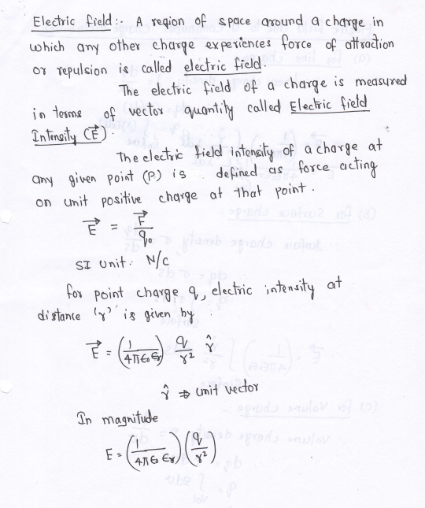
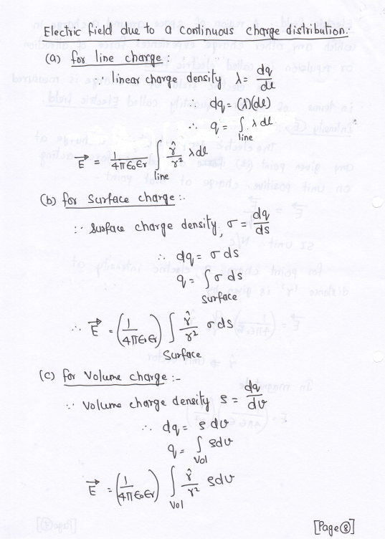

- What is Gauss’s law for electrostatics? Obtain its integral and differential form.
Ans: Gauss's law states that the total electric flux through a closed surface is equal to the total charge enclosed by that surface divided by the permittivity of the medium.
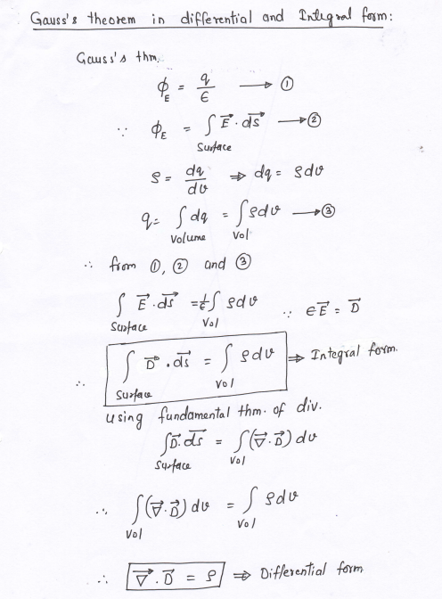

- What is electric potential. Obtain relation between electric intensity and electric potential.
Ans:
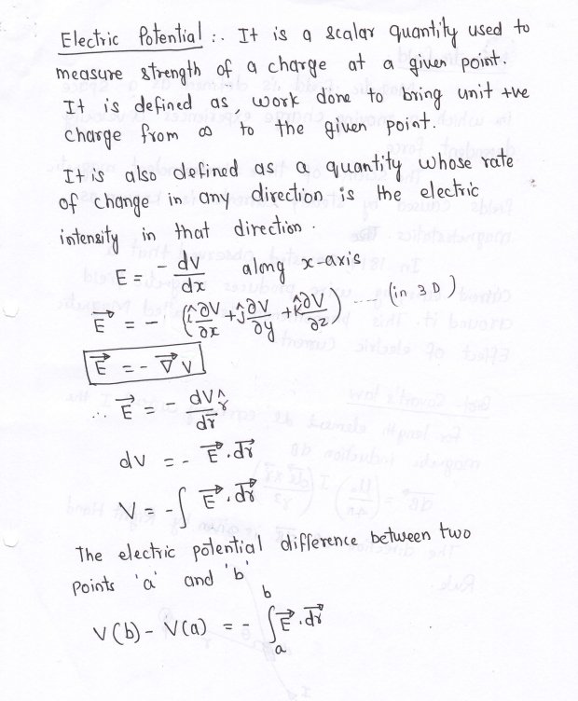
- What is Ampere’s law for magnetism? Obtain its integral and differential form.
Ans: Definition: Ampere's circuital law states that the line integral of the magnetic field intensity H^() around a closed path is equal to the current enclosed by that path.
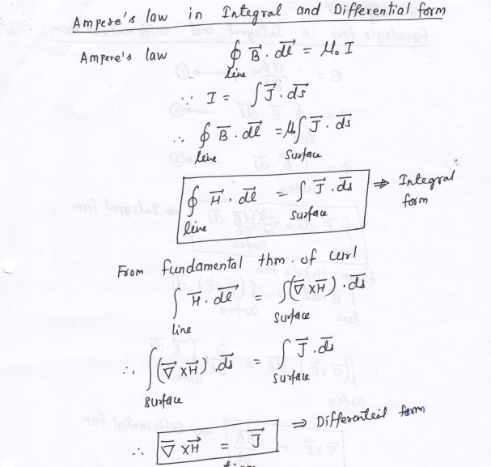
- What is Gauss’s law for magnetism? Using this prove that magnetic poles do not exist(monopole).
Ans: Gauss's Law for Magnetism: The law states that the net magnetic flux through a closed surface is zero.
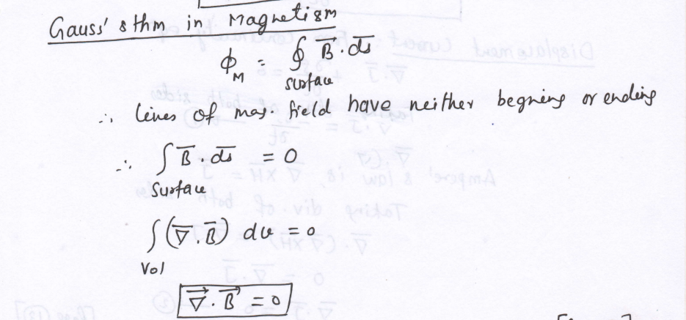
- Proof of non-existence of magnetic monopoles: The equation
implies that the net magnetic flux through any closed surface is zero. Physically, this signifies that magnetic field lines form continuous closed loops; they do not begin or end at a point (unlike electric field lines which originate from charges).
Because there is no net "source" or "sink" for magnetic flux, isolated magnetic poles (monopoles) do not exist.

- What is Faraday’s law of electromagnetism? Obtain its integral and differential form.
Ans: Definition: Faraday's law states that the electromotive force (emf) induced in a closed loop is equal to the negative rate of change of magnetic flux through the loop.
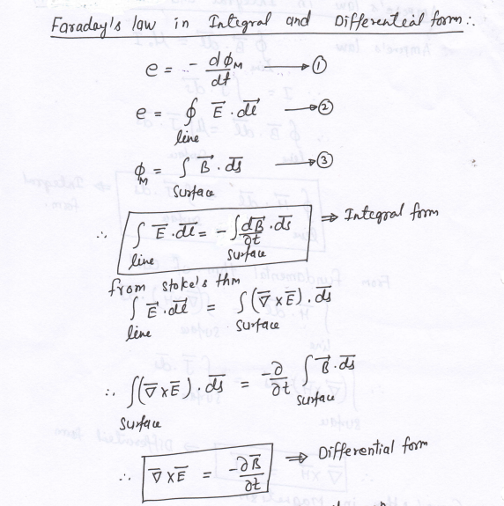

- Why Maxwell modified Ampere’s law? Obtain modified Ampere’s law. What is displacement current.
Ans: Maxwell found an inconsistency in Ampere's law when applied to non-steady currents (e.g., a charging capacitor). The continuity equation conflicted with the divergence of the original Ampere's law. To satisfy the continuity equation, Maxwell added a term.
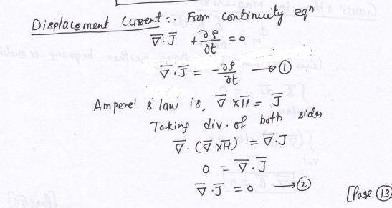
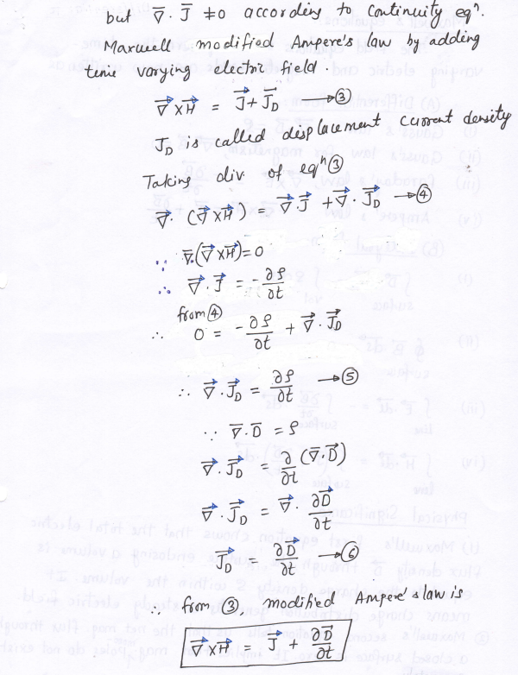

Displacement Current: The term 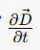 is called the displacement current density. It represents a current produced by a time-varying electric field, which produces a magnetic field just like a conduction current.

- Write all four Maxwell’s equations in differential or integral form. Explain their significance.
Ans:
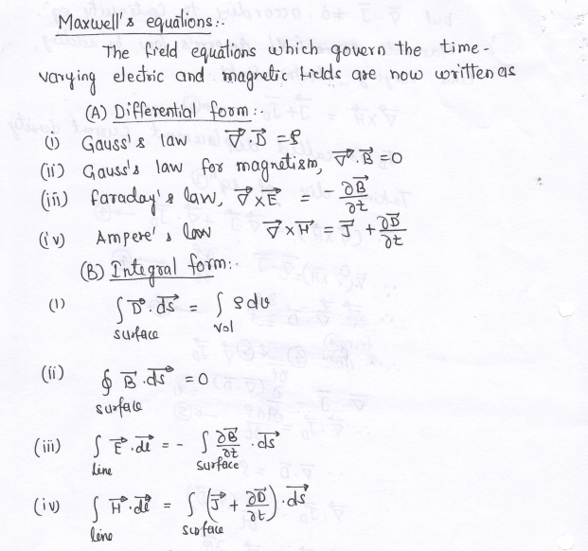
Physical Significance:
- Shows that the total electric flux density through a surface enclosing a volume equals the charge density within it; a charge distribution generates a steady electric field.
- Shows that net magnetic flux through a closed surface is zero, meaning magnetic monopoles do not exist.
- Shows that the EMF around a closed path equals the time derivative of magnetic flux density; a time-varying magnetic field generates an electric field.
- Shows that magneto-motive force around a closed path equals conduction current plus the time-derivative of electric flux density; a time-varying electric field generates a magnetic field

- Using Maxwell’s equations in free space obtain formula for speed of electromagnetic wave. Prove that light is an electromagnetic wave.
Ans:
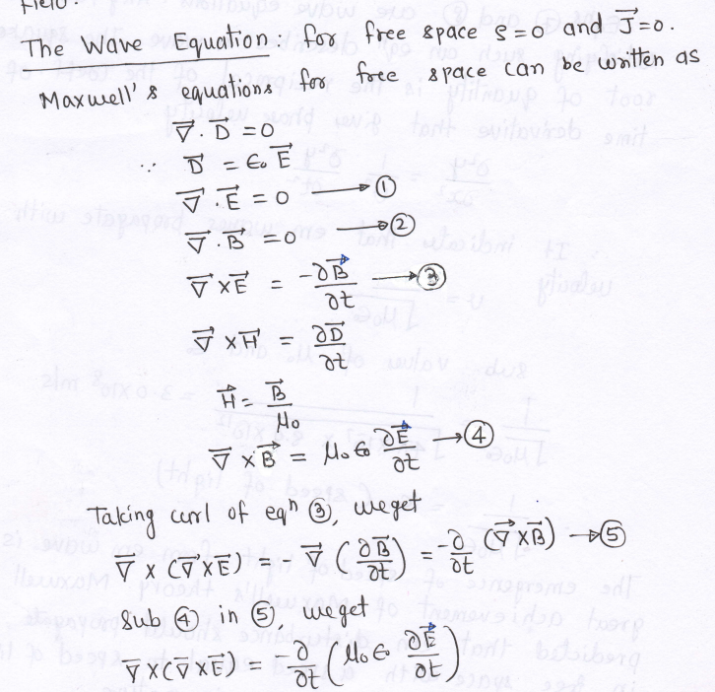
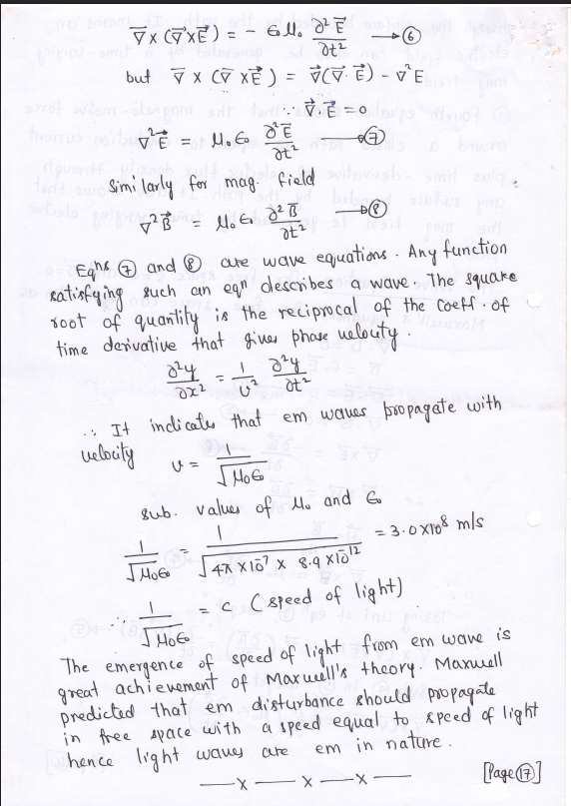

- What is unpolarised and plane unpolarized light? How is it obtained? Give their representations.
- Ans: Unpolarized Light: Light in which the vibration of the electric field vector is in all directions perpendicular to the direction of propagation.
- Polarized Light: Light in which the vibration of the electric field vector is confined to a specific direction perpendicular to propagation. (Note: The prompt asks for "plane unpolarized," which appears to be a typo in the source query based on the provided text; the text defines "polarized light").
- How Obtained: Polarized light is obtained through the process of polarization. Methods mentioned in the text include:
  - Reflection (Brewster’s Law)
  - Refraction
  - Selective absorption (Polaroids)
  - Scattering
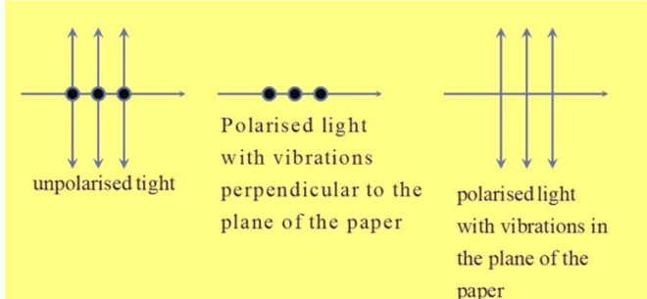
- Write a note on application of electromagnetic theory (EMT) in Wi-Fi, antennas and bluetooth.
Ans: Wi-Fi: Wi-Fi stands for Wireless Fidelity. It is a wireless communication technology based on the transmission of electromagnetic waves, operating at frequencies of 2.4 GHz and 5 GHz. Antennas in Wi-Fi convert electrical signals into EM waves and vice versa. It enables wireless connectivity for smart devices and IoT.
Antennas: Antennas operate based on the propagation of electromagnetic waves. An alternating current produces time-varying EM fields that separate and propagate as waves. Key EMT applications in antenna design include impedance matching (for maximum power transfer), determining radiation patterns (based on EM field distribution), and determining antenna size (e.g., λ/2 dipole) based on wavelength.
Bluetooth: Bluetooth uses electromagnetic waves for short-range wireless communication (approx. 10–100 m). It operates in the 2.4 GHz ISM band. Data is transmitted through oscillating electric and magnetic fields. EMT principles are used in antenna design, power control (to reduce radiation), and interference management (Frequency Hopping Spread Spectrum) to avoid overlapping with other devices like Wi-Fi.

Module 2 – 10 marks

1. Setup Time Dependent Schrodinger Equation (TDSE).
2. Staring from TDSE, obtain Time Independent Schrodinger Equation (TISE).
3. Using TISE, discuss motion of a particle in a one-dimensional box (infinite potential well).
4. Using mathematical derivations, show that the energy of a particle confined in a one-dimensional box is quantized.
5. Derive an expression for energy of a particle confined to infinite potential well.
6. Write formulas of energy and wave function of a particle in a one-dimensional box. What are eigen value and eigne functions.
Ans:
7. Discuss quantum tunneling phenomenon in brief.
Ans:
- Definition: Quantum tunneling occurs when an electron hits an energy barrier that it technically does not have enough energy to cross (E<V), yet there is a small probability that it appears on the other side.
- Mechanism: The particle does not break the barrier; it essentially "leaks" through it. The wave function decays exponentially inside the barrier. If the barrier is thin enough, the wave function does not reach zero before exiting, meaning there is a non-zero chance of detecting the particle on the other side.
- Sensitivity: The probability of transmission (I) is an exponential function of the barrier width. Doubling the width can drop the probability by a factor of 1,000 or 1,000,000.
- Applications: This phenomenon is used in Flash memory (USB drives & SSDs) where electrons tunnel onto a floating gate to store data, and in Scanning Tunneling Microscopes (STM) to map atomic surfaces.

8. Write a note on the quantum mechanics of nanoparticles.
Ans:
- Dimensional Confinement: In the macroscopic world, properties are fixed (e.g., gold is yellow). At the nanoscale (1–100 nm), classical physics rules collapse, and confinement leads to "tunable" properties.
- Quantum Effects: When a material is smaller than the exciton Bohr radius, its energy levels split into discrete quantized levels rather than continuous bands.
- Material Properties: Size rewrites the identity of materials. For instance, bulk gold is yellow, but gold nanoparticles can appear red or purple. Bulk silicon is an indirect semiconductor, but nano silicon shows enhanced luminescence.
- Core Idea: By restricting the freedom of electrons through confinement, we gain the freedom to design properties like color and conductivity.
9. What are tunable quantum dots? Explain blue and red emission
Ans:
- Tunable Quantum Dots: Quantum dots are 0D nanostructures where electrons are confined in all three directions, resulting in fully discrete energy levels. They are called "tunable" because their physical properties (like light emission) can be controlled by changing their size.
- Blue Emission: Small dots have a large bandgap. When an electron-hole pair recombines, it emits higher-energy light, which corresponds to blue emission.
- Red Emission: Large dots have a small bandgap. They emit lower-energy light, which corresponds to red emission.

Module 1 – 5marks
1. With a neat, labelled diagram of pn junction diode at equilibrium, derive an expression for barrier potential.
Ans:
2. Explain working of pn junction diode in forward and reverse bias.
Ans:
- Forward Bias: The positive terminal of the battery is connected to the P-region and the negative to the N-region. Holes in P and electrons in N are repelled towards the junction. This decreases the width of the depletion region and the potential barrier. Majority carriers diffuse across the junction, resulting in a large current.
- Reverse Bias: The negative terminal is connected to P and positive to N. Majority carriers are attracted away from the junction. This increases the width of the depletion region and the potential barrier. Diffusion of majority carriers stops. Only minority carriers are swept across the junction, creating a small constant current called "reverse saturation current."

3. Plot diode characteristics for forward and reverse bias. What are static and dynamic
resistance. Write their formulae.
4. Explain working of pn junction as half wave rectifier.
5. Explain working of pn junction as full wave rectifier.
6. Write note of Zener diode. How it is used as regulator
7. What is Schottky diode? Explain its working and state two applications.
8. Explain in brief the construction and working of PNP or NPN transistors.
9. What are the various configurations in which transistors are used? Draw
appropriate diagrams.
10. What are the current gains for Common Base (CB) and Common Emitter (CE)
configurations of transistor? Obtain relations between them.
11. Draw circuit diagram and explain the typical input and output characteristics of CB
configuration of Bipolar Junction Transistor (BJT). Mention few salient features.
12. Draw circuit diagram and explain the typical input and output characteristics of CE
configuration of BJT
13. What is the early effect? What is Q point? Explain its significance briefly. Draw
necessary diagram?
14. With appropriate diagrams, explain working of BJT as the switch.
15. What is Metal Oxide Semiconductor (MOS)? Explain its working and state few
applications
16. What is Charge Storage Mechanism in Metal Oxide Semiconductor Flash Memory
Device
17. Explain construction and working of Light Emitting Diode. state its three advantages
and disadvantages.
18. Explain construction and working of a laser diode. Give applications of Laser Diode

19. Explain working principal of photodetector. What are different types of
Photodetectors
20. With neat diagram explain construction and working of a solar cell
21. Write five points to distinguish between laser diode and LED.

